吉林大学

DB2实验报告

班级：552410
姓名：柳湛博
学号：55241019

姓名 | 柳湛博 | 学号 | 55241019
实验项目 | 8. Investigating DB2 locking
实验性质 | □演示性实验 □验证性实验  操作性实验 □综合性实验
实验地点 | A108 | 机器编号 | 10
指导教师 | 刘雪洁 | 实验时间 | 2026年 9 月 29 日 6 时 15 分
一、实验综述
1. 实验目的及要求
In this exercise, you will use the system monitor to analyze locking occurring on your database. You will use the DB2 Control Center, DB2 Command Editor, and DB2 Command Window to represent transactions accessing your database.
At the end of the lab, students should be able to:
• Use the Snapshot Monitor to perform basic lock monitoring
• Distinguish between lock timeouts and deadlocks
• Update database configuration parameters related to timeouts and deadlocks
2. 实验设备、软件
PC, windows XP Professional, DB2 9 Express-c
二、实验过程（实验步骤、记录、数据、分析）
Section 0 - Setup
- For Windows:
- Open the first DB2 Command Window.
- Select Start > Programs > IBM DB2 > DB2COPY1 > Command Line Tools > Command Window.
- Open a second and third Command Window. Within the first DB2 Command Window, type db2cmd and Enter. Do this again, so that you have three Command Windows open.
- In one Command Window, change the window title to student.
Type:
title student
cd C:\labfiles\cf23
In the second Command Window, change the window title to db2admin.
Type:
title db2admin
cd C:\labfiles\cf23
In the third Command Window, change the window title to monitor.
Type:
title monitor
cd C:\labfiles\cf23
Show your work below by printing screen.
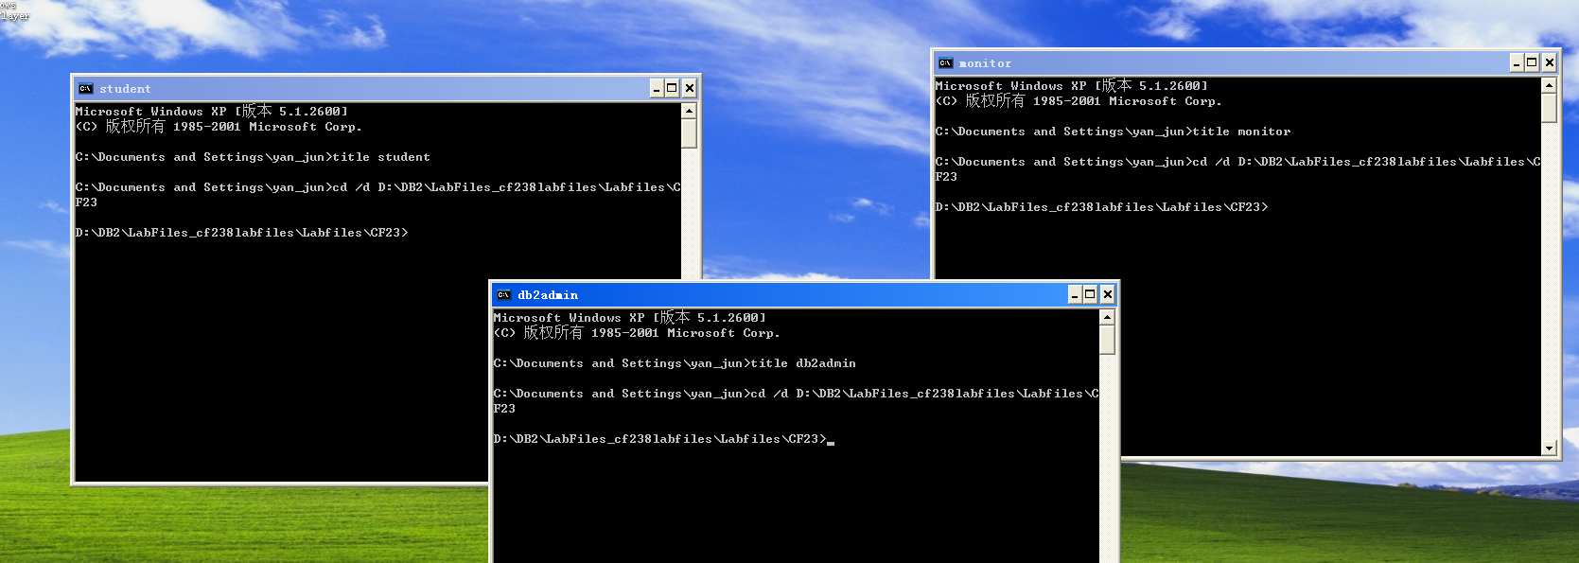

Section 1 - Basic Lock Monitoring
1. From your monitor window, execute the following commands to ensure that no connections exist to your instance:
db2 force application all
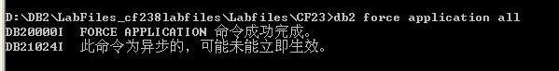
2. From your monitor window, grant update privilege against the STOCK table to db2admin.
db2 connect to musicdb
db2 grant update on stock to user db2admin
Show your work below by printing screen.
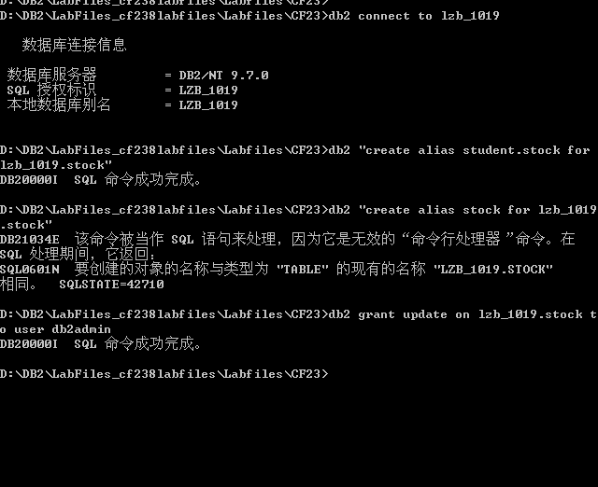
3. From your monitor window, examine the current setting of the database monitor switches by issuing the following:
db2 get monitor switches
Show your work below by printing screen.
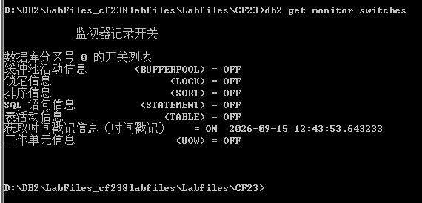
4. What is the current setting of every switch?
默认情况下，大多数开关处于 `OFF` 状态，只有时间戳记是开着的

5. Will the system database monitor provide ANY information concerning locks?
如果 LOCK 开关是 OFF，系统监视器将不会收集和提供详细的锁等待时间等信息，只能提供非常有限的基础连接信息。

6. From your db2admin window, connect to the musicdb database and update a single row in the STOCK table. DO NOT commit the change. Use the CLP command option of +c. The +c CLP command option must be used to prevent automatically committing an SQL statement. Follow your lab instructions carefully!
db2 connect to musicdb user db2admin using ibm2blue
db2 +c "update student.stock set qty = qty - 1 where itemno = 200 and type = 'D' "
Show your work below by printing screen.
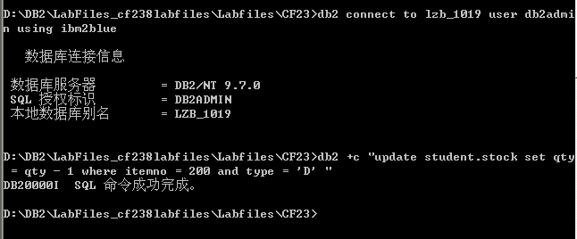

7. From your monitor window, list the agents associated with the two CLP applications you currently have connected/attached to this instance.
db2 list applications show detail
Record the results below. You will find the Application Handle useful during
subsequent portions of the lab.
student Application Handle = _____2786_____________
db2admin Application Handle = ___2796_______________

8. From your monitor window, examine the database monitor elements related to locking by issuing the following:
db2 get snapshot for locks on musicdb > lock1.out
notepad lock1.out
Show your work below by printing screen.
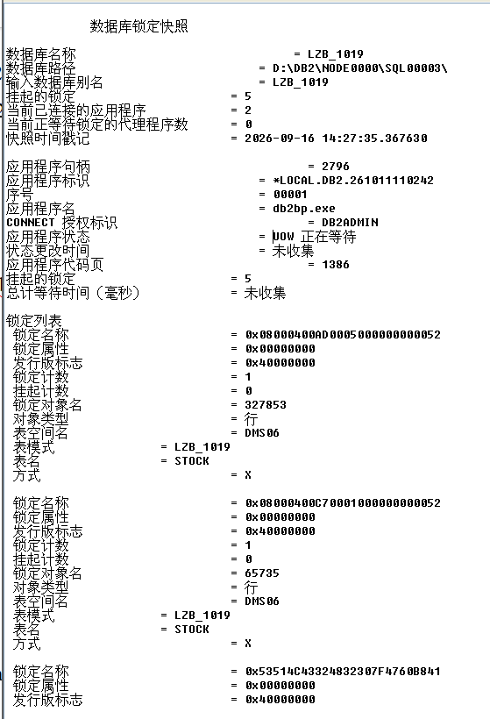
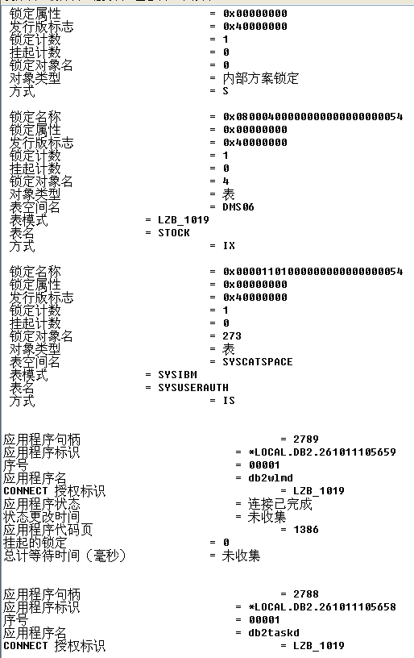
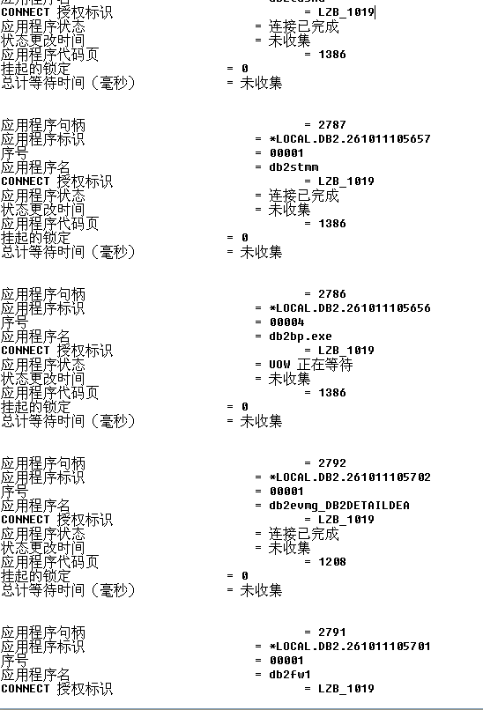
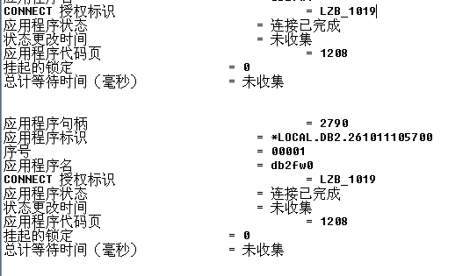

9. Are any locks currently held?
是的，持有锁

10. How many applications are currently connected?
2

11. What agents are currently holding locks? What applications are associated with this/these agents?
拿着锁的 agent 是对应 `db2admin` 用户的连接。应用名称为 db2bp.exe

12. Is there ever a case where a row lock is possessed without a corresponding lock on the table which contains the row?
No 。在获取行锁之前，数据库必须首先在表级别获取意向锁。
13. What lock modes are shown for tables under which a row is locked?
IX

14. How many different tables are being locked by the agent?
2
15. It may be that you will see catalog tables being locked. Why might catalog tables be accessed?
因为在执行更新时，DB2 需要访问系统目录表以检查用户权限、表结构、约束和索引等元数据信息。
- Exit the Notepad session
Section 2 - Lock Timeouts
1. From your student window, issue the following SQL statement:
db2 connect to musicdb user student using ibm2blue
db2 "select * from stock where itemno = 198"
Show your work below by printing screen.
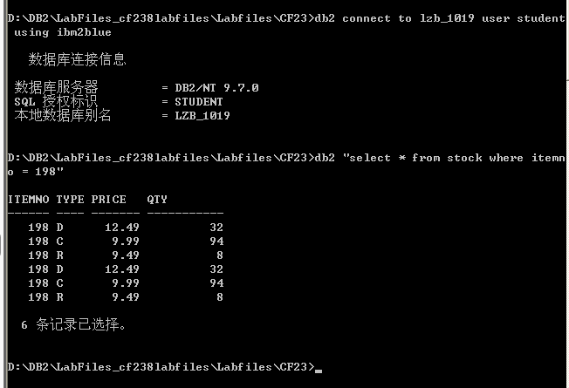
2. What happened and why? (Recall that you currently have a row where itemno = 200 locked by the db2admin application.)
查询正常返回了结果。因为 `db2admin` 修改并锁定的是 `itemno = 200` 的行，行锁不会阻塞对其他未锁定行（`itemno = 198`）的读取。
3. From your student window, issue the following SQL statement:
db2 "select * from stock where itemno = 200"
Show your work below by printing screen.
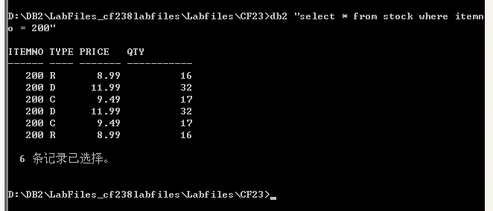
- What happened and why? (Recall that you currently have a row where itemno = 200 locked by the db2admin application)
执行 select * from stock where itemno = 200 后，查询成功返回 3 条记录。三条记录的 ITEMNO 均为 200，但 TYPE 分别为 D、G、R，对应价格为 11.99、9.49、8.99，库存数量为 32、17、16。说明 WHERE itemno = 200 条件能够查询出该商品编号下的所有不同类型记录。该语句为查询操作，不会修改表中数据，查询结果与数据库中的实际数据一致。

- Did table locking cause the contention problem?
No，是行级锁 (Row Lock) 冲突导致的，而非表锁。
- You have not done anything in the lab environment to change the isolation level in the student window. Consider this and your results from the past two SQL statements issued from the student window. If given a choice between Uncommitted Read and Cursor Stability, which one do you think is the default isolation level for the student window?
默认隔离级别是 Cursor Stability（CS，游标稳定性）。论证理由：如果默认隔离级别是未落实读（UR, Uncommitted Read），则事务在执行 `SELECT` 读取数据时根本不需要获取行级共享锁（S 锁），它可以直接“脏读”未提交的脏数据页，绝不会被 `db2admin` 的行级 X 锁阻塞！正是因为当前窗口在读取 `itemno = 200` 时发生了锁等待挂起，证明其必须获取 S 锁且遵循锁相容原则，这完全符合 游标稳定性（CS）的特征。因此 DB2 的默认隔离级别必然是 CS。
7. From your db2admin window, issue the following to release the row lock.
db2 rollback
Show your work below by printing screen.
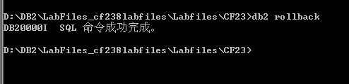
8. Did the waiting application continue?
Yes。db2admin 回滚后锁被释放，student 窗口的查询瞬间完成并显示出结果。
9. From your monitor window, examine the database configuration parameter
concerning lock timeout by issuing:
db2 "get db cfg for musicdb" | more
Show your work below by printing screen.
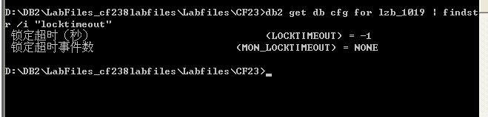
10. Check the value of the locktimeout parameter. If you had decided to get a cup of coffee while the original X lock was held on the row your other application was trying to read, would the situation have changed, even if you took 15 minutes to consume mass quantities of liquid refreshments?
默认值通常是 `-1`。意味着应用程序将无限期地等待锁。
11. From your monitor window, change the locktimeout parameter to 90 seconds by issuing the following commands: Also, update the monitor switches to turn lock and uow on.
db2 terminate
db2 force application all
db2 update db cfg for musicdb using locktimeout 90
db2 update monitor switches using lock on uow on
db2 connect to musicdb
Show your work below by printing screen.
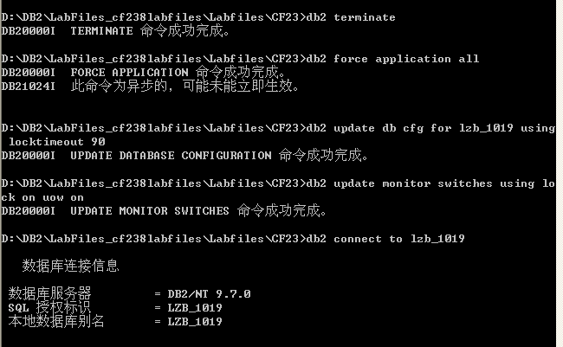
12. How much time is designated by the locktimeout parameter?
90秒
13. What occurs by updating the monitor switch for lock to on? (The uow functional group setting to on is used in a later step.)
开启了详细的锁事件监控，DB2 将收集诸如锁等待时间、发生超时的次数和死锁次数等信息。
14. From the student window, you decided that the work being performed by the
student user needs an isolation level of RR. What command could be used to
change your isolation level for the student window to Repeatable Read? Document
your command below and attempt to execute it. Were you successful?
命令为 db2 "set current isolation = RR"。执行该命令可以成功修改隔离级别。
成功了
15. Enter the following from the student window where you now have isolation level set to Repeatable Read.
db2 connect to musicdb user student using ibm2blue
db2 +c "select * from stock where itemno = 200"
Show your work below by printing screen.
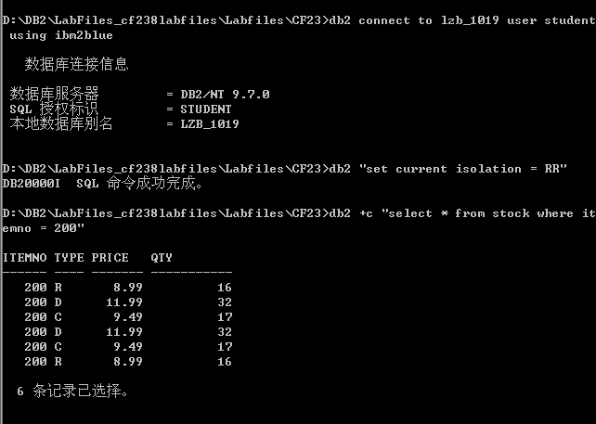
16. From your monitor window, obtain a snapshot and state the number of row locks against the STOCK table that the student application holds.
db2 get snapshot for locks on musicdb > lock2.out
notepad lock2.out
Show your work below by printing screen.
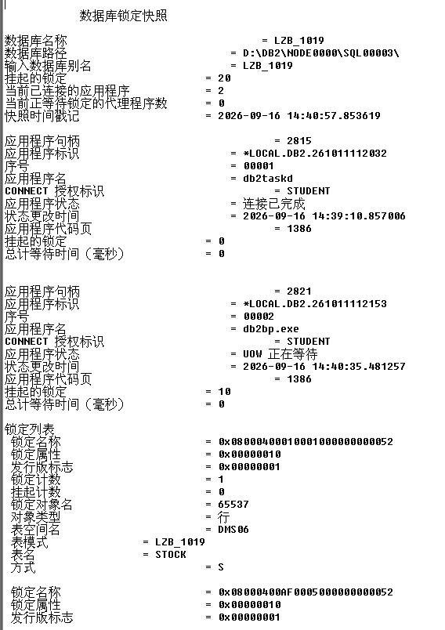
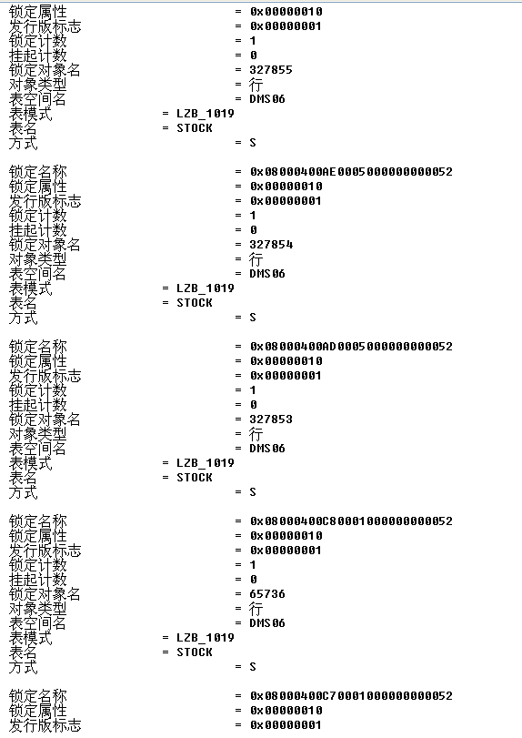
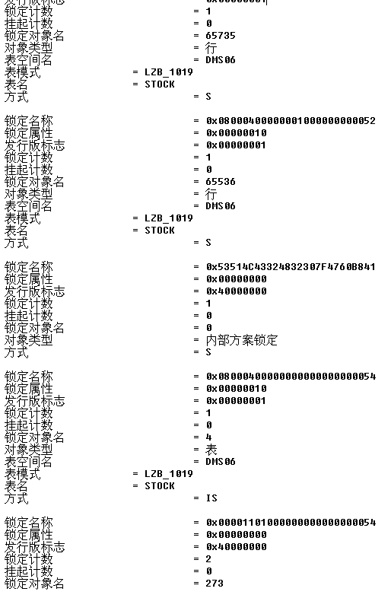
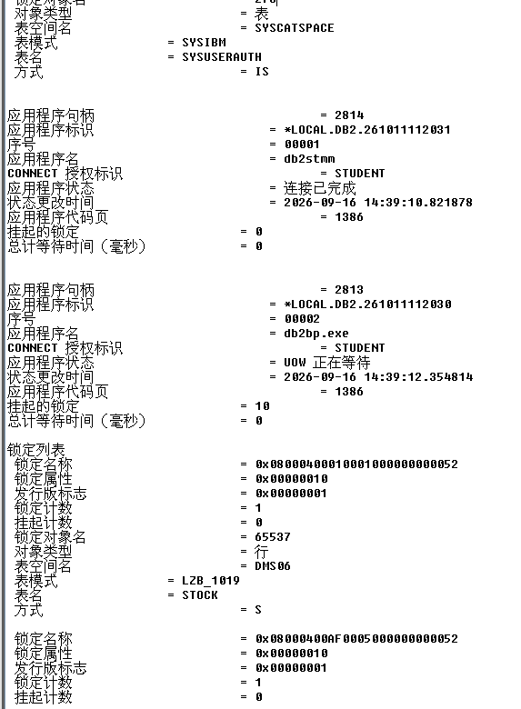
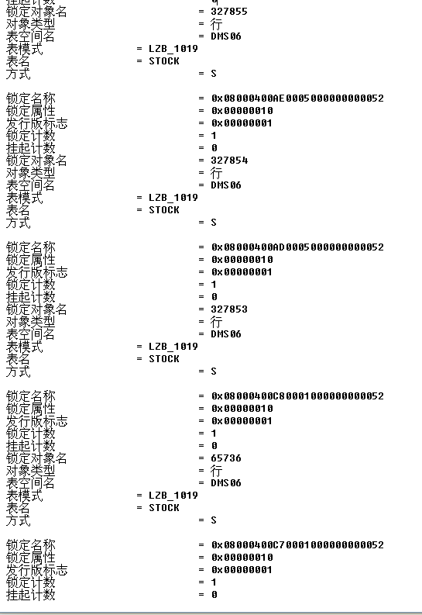
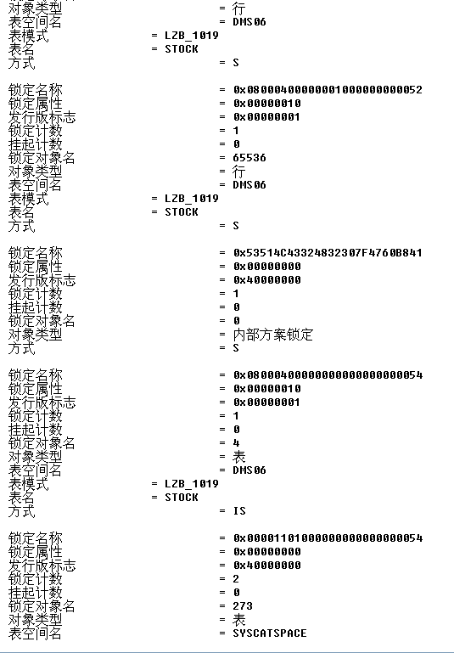
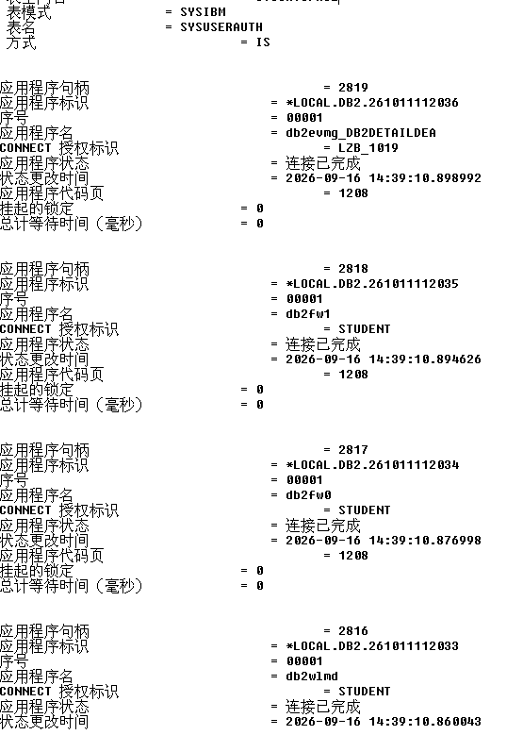
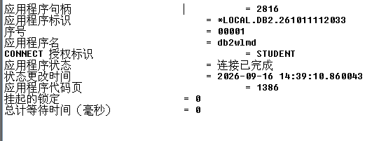
可见存在S锁
17. Exit the Notepad session.
The next two steps require you to obtain a snapshot before your 90 second
timeout period expires.

18. From your db2admin window, issue the following:
db2 connect to musicdb user db2admin using ibm2blue
db2 +c "update student.stock set qty = qty + 1 where itemno = 200 "
Show your work below by printing screen.
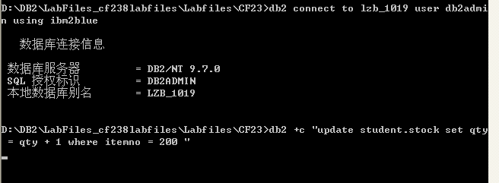
19. It appears that db2admin is in a lock wait. Investigate this condition by getting
another snapshot from your monitor window.
db2 get snapshot for locks on musicdb > lock3.out
notepad lock3.out
Show your work below by printing screen.
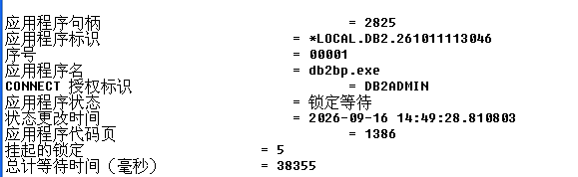
20. Analyze the portion of the snapshot that is related to the db2admin application. Can you suggest the object that is causing the contention?
导致争用的是 `STOCK` 表中 `itemno = 200` 的这行数据。
21. Exit the Notepad session.

22. If your db2admin application is still waiting, sit back and relax for a minute or so. Eventually, something should happen. What message is returned to the db2admin application and why?
会返回 `SQL0911N The current transaction has been rolled back because of a deadlock or timeout. Reason code "68".`。原因是达到了我们刚才设置的 90 秒 `locktimeout` 阈值。
23. Roll back the unit of work in the student window to release the share locks.
db2 rollback
Show your work below by printing screen.
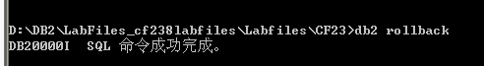
24. Is it necessary to roll back the update attempted by the db2admin application? Why or why not?
No。发生锁超时后，DB2 会自动将引发超时的该事务（db2admin的事务）回滚。
Section 3 - Deadlocks
1. Examine the deadlock check time parameter currently active for your database by issuing the following from your monitor window.
db2 get db cfg for musicdb | more
Show your work below by printing screen.
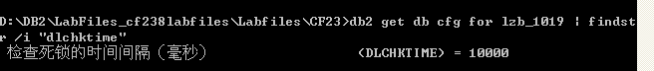
2. What is the value and how much time does this designate?
10秒
3. Issue the following series of SQL statements. Pay particular attention to the window from which you submit the statements and the order of the statements. Execute steps a and b, then for Steps c and d below, enter the SQL for Step c, but don't execute. Then enter the SQL for Step d in its window, but don't press Enter. Now go back to Step c's window and execute. Then press Enter from Step d's window. This will insure that the timeout parameter you have set will not interfere with the intention of the exercise. Remember... we want the isolation level set to Repeatable Read in our instnn window.
a. student => db2 +c "select * from stock where itemno = 100"
b. db2admin => db2 +c "update student.stock set qty = qty + 1 where
itemno = 200"
c. student => db2 +c "select * from stock where itemno = 200"
d. db2admin=> db2 +c "update student.stock set qty = qty + 1 where itemno = 100"
Show your work below by printing screen.
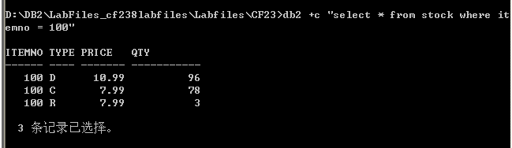
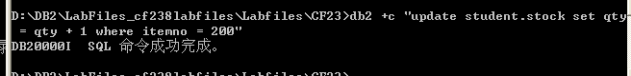
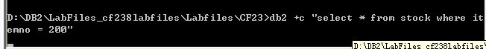
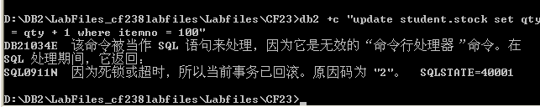
4. What did you observe? Why did this occur?
观察到发生了死锁 (Deadlock)。因为 `student` 持有行 100 的 S 锁并等待行 200，而 `db2admin` 持有行 200 的 X 锁并试图获取行 100 的 X 锁，形成了循环等待
5. Obtain a snapshot from your monitor window. This time, request an applications snapshot.
db2 get snapshot for applications on musicdb > appl.out
notepad appl.out
Look for the item UOW completion status for each application.
Show your work below by printing screen.
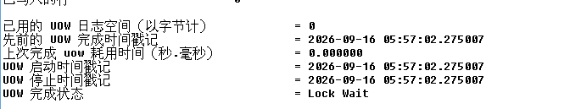
6. What is the status for the application associated with the student window? Why is this the case?
student 窗口的应用处于 UOW Waiting（工作单元等待） 状态。因为 student 已经对 ITEMNO=100 的记录持有共享锁，但继续查询 ITEMNO=200 时，需要等待 db2admin 释放该记录上的排他锁。
7. What is the status for the application associated with the db2admin window? Why is this the case?
db2admin 窗口的应用也处于 UOW Waiting（工作单元等待） 状态。因为 db2admin 已经对 ITEMNO=200 的记录持有排他锁，但更新 ITEMNO=100 时，又需要等待 student 释放共享锁。
两个应用互相持有对方需要的锁，形成循环等待，因此产生死锁。DB2 的死锁检测机制随后会选择其中一个事务作为牺牲者并回滚，另一个事务才能继续执行。
8. Exit the Notepad session.
9. Release the locks held by the student window application.
db2 rollback
Show your work below by printing screen.
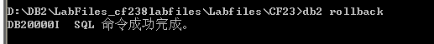
10. Highlight the difference between deadlock and timeout by entering the following series of commands and SQL statements:
a. student => db2 +c "select * from stock where itemno = 100"
b. db2admin => db2 +c "update student.stock set qty = qty + 1
where itemno = 200"
c. student => db2 +c "select * from stock where itemno = 200"
Show your work below by printing screen.
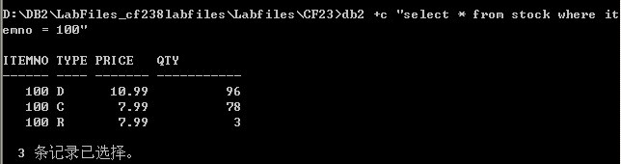
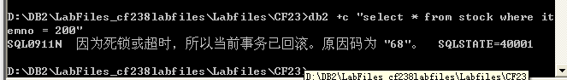
11. Wait for the database manager to take some action. What action did the database manager take? Why is this the case?
经过约 90 秒后，student 窗口报 `SQL0911N Reason Code 68` (超时)。因为这里没有形成循环等待，只是一方在等待另一方释放锁，触发的是 Timeout 而不是 Deadlock。死锁 (Deadlock) 会被 DB2 后台进程 (dlchktime) 每 10 秒快速检测到并终结其中一个事务(Reason code 2)。
12. Roll back the changes requested by the db2admin window.
db2 rollback
Show your work below by printing screen.
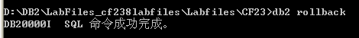
13. Make a general statement about the relationship of the configuration parameters dlchktime and locktimeout.
dlchktime` 控制死锁检测器多久运行一次寻找死循环等待（通常很短，如 10s）；而 `locktimeout` 决定了一个事务愿意为了获取锁而等待多长时间（单向等待）。`dlchktime` 应该始终设置得比 `locktimeout` 短很多，以便能够及时发现和解决死锁，而不是让应用白白等待直到超时。

Section 4 - Resetting the Environment
Perform the following tasks to reset your system for the remaining labs.
1. Exit your db2admin window by typing:
exit
2. Exit your student window by typing:
exit
3. From your monitor window, execute the following:
db2 revoke update on stock from db2admin
db2 update monitor switches using lock off uow off
db2 force application all
4. Exit from your monitor window:
exit
